Meeting Minutes – October 21, 2016
- More t-shirts
  - Long sleeve/short sleeve
  - Contest for design --> Get a free French@Elmhurst T-Shirt
  - We will have the front look something like this, and the back design is to be determined! Remember: the more colors, the more expensive.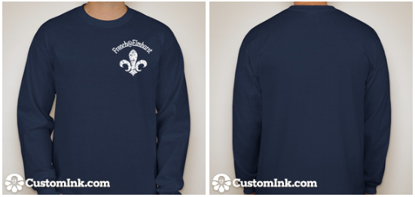
- Pinstripes
  - Dec 14 or 15, 9p-11p
- Potential interest in a Film Festival here on campus
- French Immersion Night, Nov 4 – Sign Up!
- Watched "Le Café" and the FRN-335 contest video
- COD Game Night http://www.afdupage.com/special-events.html
  - Wednesday, Oct 26 7-9pm
  - FREE FOOD
  - Ask Mitchell Garcia if you have questions/Check the French@Elmhurst Facebook page
- L'alliance francaise de DuPage events
  - Baguette cooking event

